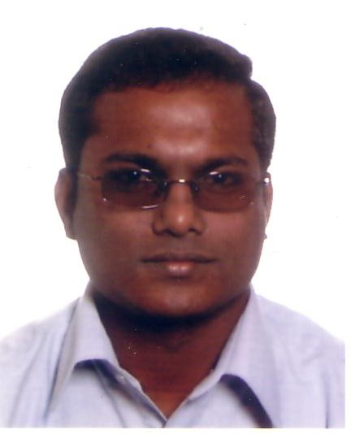Autobiography of Bro. Sebastianpillai (Alphonsupillai)
My name is Sebastianpillai; I was born in Kattaikadu, a local hospital in the North Western Province of Sri Lanka, on the 8th of April 1976. I have two brothers and one sister.

When I was ten or eleven years old I lost my parents. My father died by heart attack, and my mother died by accident. This was a very sad incident in my life. Three months after I lost my parents, I went to the orphanage hostel in Kalmunai. I stayed there during my studies. The orphanage is in the Eastern Province of Sri Lanka. I studied there for my secondary education during six years. When I finished my school studies in 1993 I joined the Congregation of the Brothers of St, Joseph to become a religious.

I started there one year for Postulancy; that was in 1994. After one year I started my novitiate in Kalmunai in 1995. During the novitiate time I studied the constitutions of the Brothers of St. Joseph and the catechism of the Catholic Church. When I made my first profession, in 1996, I went for mission work to Trincomalee, in the East of Sri Lanka. For four years I worked there, and in 2000 I was transferred to Kalmunai. I worked in Kalmunai as a catechism teacher until 2002. On 2002 I did my final profession.

In 2002 the Congregation of the Brothers of St. Joseph joined with the Brothers of Charity. After the amalgamation I transferred to Kandy in the provincialate. I was there for two months. After two months I was transferred to Ja-Ela in the Western Province of Sri Lanka. There the brothers are taking care of children with a handicap.

I started working with them from 2004 to 2006. I really enjoyed working with those children, because they need our help and love. After completing my studies in Belgium I would like to go back to my country and to work there with children with a handicap.

