My name is Bro NSENGIYUMVA NYAKASANE Ghislain, and my friends call me “Kaka Golf”.
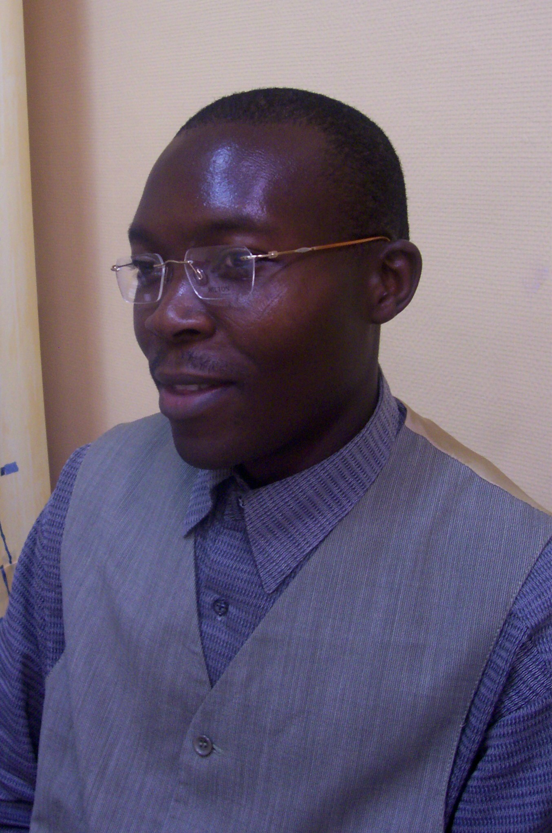
In the year of 1974, Tuesday, April 29th I was born in the eastern part of the Democratic Republic of Congo/ Bukavu. I’m coming from a Christian family as the first born of eight children among them four sisters and three brothers.
All my parents are still alive, thanks to God’s care for them and all my younger brothers and sisters.

I joined the congregation of the brothers of charity in 1998 as a POSTULANT after finishing my secondary school in Pedagogy, (This period of formation was for two years in Bukavu).

The second part of my initial formation was my novitiate; that experience as novice took place in BELGIUM in the International Novitiate, Sint Maria-Alter. (2000-2002). This period is always divided in a canonical year: the second year in two parts, I mean six months of apostolic training and six months of experience in our own countries.

I choose to do SPECIAL EDUCATION program in the Prebaccalaureate level for six months, to get knowledge and skills also be able to serve people with confidence back in my own country.

On August 8th, 2002 I made my first religious profession as Brother of charity in NAIROBI – KENYA. This event was followed by a one year formation in spirituality and education. Life went on when I saw myself be called back to Bukavu from Kenya, to work as responsible of our formation house. Meanwhile the time came when I had to renew my vows, and it was done in June 6th, 2004. Till the end of the year 2005 I stayed in our formation house and serve my community in different ways too.

Finally at the beginning of this year (2006 till the end of 2007) I’m following the associates program in special education here in Belgium, in order to improve my knowledge and professional skills in the field of education, especially by working with people having physical disabilities. The program is offered in the collaboration with the Catholic University of America (CUA) in Washington, DC. Both formal classes and internship experiences are included in this 60-credit program.

Thank you and God bless!

