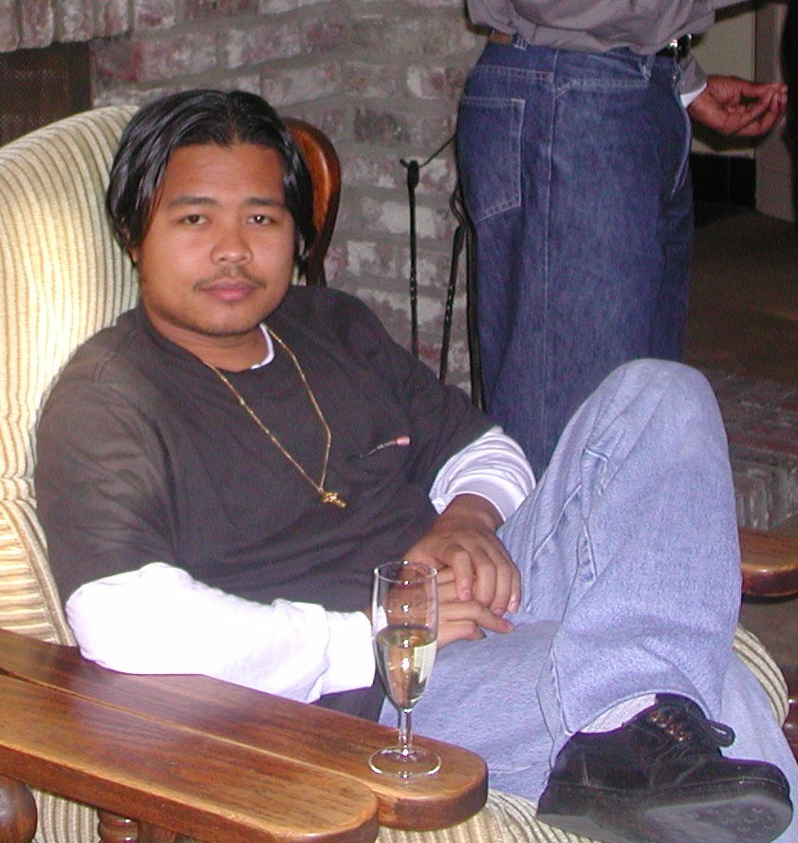

My name is Jonie Gernale Gibaga. I am 27 years old, and I was born on 23, February 1978 after the six years of Martial law in Baranggay San Ramon Bulan, Sorsogon, Bicol Region V, Philippines. People called me Jonie Boy. I belong to a poor family. My father’s name is Pancho Gloriane, Gibaga from San Ramon. He died last October 23, 2005 at the age of 54. He was a good example to us. He had a strong faith in God even though he couldn’t go to church every Sunday. And in spite of difficulties in life he never lost his hope every time he went out of our house to find a job for our food. A very industrious man, he was always making jokes that could make his friends happy. He was also a guitarist and singer. My mother’s name is Alma Giba, Gernale from San Juan Bag- O. She is our light in our house, very courageous and industrious. She comes from a farming family. Both of their parents made a decision that they should that they should marry. I have five brothers, two sisters, and I am the eldest in our family.

It was 1984 my family started to moved from one village to another because of my father’s work. Sometimes we lived in the mountain and sometimes in the rice fields. It is always in my these sentences that I say that ‘there’s no place like home’. My grandparents taught me to plant and harvest rice, sweet potatoes, cassava and other root crops in the mountain. At 1985 we went back to San Ramon to start my study in primary school. The first year of my schooling I received a second honor award. It was about in the middle of my second grade that my parents had many difficulties in life. Poverty and some misunderstanding between the sister of my father and my mother pushed us in the middle of the night going to the house of my mother’s parents. The following day they decided to go to Manila. My study stopped for the moment because my mother didn’t want us to stay in Bicol without her. For our sake my father followed my mother’s decision. They worked on a chicken farm. It was too difficult for us to find a good place and house to stay in. I followed in the catechism for six months of 7th Day Adventist instruction, one of the big sects in the Philippines. I met young streets friends and they taught me to find money in the garbage. I become a street child for sometime every Sunday because that was my only free time. But our parents worried about our study time and our future. That’s why they decided to go back in our province. In 1988 I started my class in 2nd grade to 4th grade and I always had an honor after the end of the school. I always spent my vacation in the rice field of my grandparents in my mother’s place, so that I could save money to buy new clothes, school supplies, and have money for miscellaneous supplies for school. In 1990 one of the rich family relatives of my mother asked me to stay in their house to guard the house, clean, feed the pigs and care for an old man who has a very difficult attitude most of the time. I agreed and stayed in their big house. It was my first time to be away from my family. Tears fell when the nights were falling. In June I started my 5th grade in Bulan North Central School A, a public school. I became more popular in that school being new. I belonged to the first section and some of them belonged to rich families. I am the only one who was poor in that group but they didn’t know about my life. They thought that I was also a rich young boy because it did not show otherwise in my appearance. Young ladies always came to my classroom and talked to me every vacant period but I was so shy to meet them. That’s why I hid from them sometimes. At the end of the school I received top 8th award among the class. I became in charge of the thousand sacks of rice in the stock room and of bringing foods to the workers in the farm.

But after kissing goodbye and death of the old man I tried to visit my family for the first time. It was Holy Week when I went to my Baranggay to meet my family and friends. I decided to stay with them. I didn’t go back again in the town. It was time for me to transfer again to my former school to finish my sixth grade. I became famous as president in the classroom, valley ball player, and patrol leader in the Boy Scouts. I joined in the jamboree and mathematics quiz with the financial support of my teachers because my parents couldn’t support that financially. However, they gave me a lot of moral support. Even though I didn’t want to go, my teachers always encouraged me to experience new activities, and they were very supportive. When I finished my primary school I became the valedictorian of the year. My teacher provided clothes for my graduation day. I received many certificates and gold medals. It was also my first time to meet my puppy love. Her name is Raquel Reyes a young white and beautiful girl. We only met sometimes if there was a dance party in other Baranggay. Because it is also our culture every summer season youngsters are always invited by other Baranggay for their dance party.

In 1992 I started my study in secondary school. My parents didn’t permit me to study in our town for two reasons: one is that they don’t have enough money to support my education ,and secondly they think that I will not study hard because of bad friends. Even my teachers in primary school wanted me to study in trades and agriculture school, but it was a decision of my parents to study in Alcoba National High School, a public school in San Isidro near the village. Many people wanted to support my study and invited me to stay in their house, but I said no. I joined in the drum groups and became a representative of the Student Council Organization. Many young ladies were admiring me. That’s why they were always sending letters to me and asking for advice. I met Angelina Lambojo of Matnog Sorsogon, Rochel Villaruz of Lay-a Bulan Sorsogon, Ingred Janer of San Isidro Bulan Sorsogon, Luisa Gotladera of San Isidro Bulan Sorsogon, Sheryl Melitante of San Juan Gag-O Bulan Sorsogon, Michelle Giba and Jennette Gillego of San Juan Bag- O Bulan Sorsogon . Some became my loved ones but the only one of them that I really loved was my first love. Her name is Marivic Gludo a second year student, with short, curly hair and white skin. We had been together for six years but we discovered that we were of the same blood, that we were related. So whether we like it or not we decided to stop seeing each other.

I belonged also to the mathematics group. They brought in the provincial math Olympiad. I was also a member of the science club and joined a science organization that in the provincial meetings fought against illegal finishing and logging in our province. I always had an award every end of the school year and was in the top 4th of the class. In 1994 I was in the 3rd year of my school, and I joined a lot of activities in the school. I was aspiring to become an officer in the Preparatory Military Training (PMT); I became a president of Campus Ministry Organization, president and assistance director in Community Base Theater Arts Group (CBTAG) and become a Filipino Editor in the first Campus News Letter (Voice). I won 4th place in editorial cartooning during the Provincial Campus Journalism meeting held in Gubat National High School, Gubat Sorsogon. At 1996 I was in the last year of my High School. I become President of the Student Council Organization and Corp Commander in the PMT. I stayed in my cousin teacher’s house so that she could support my needs in the school. I made the CBTAG an active giving presentation in other villages. And we presented a Death March on the street of our town and we won the first place. It was December 30, 1996, the death anniversary of our national hero. I acted the part of his life when he was fired by the Spanish Soldiers at the grand arena. People cried for that. While the Philippines national anthem was sung I was lying on the ground pretending to be dead. Till end of my school year I maintain the peace in order in our school. Students did not complain to me. But because I am only a poor boy I didn’t make some visible works but for the best of the school but I did many things. I received 3rd honor among the top students in the school.

It was my plan to escape from the security of my family and especially to my cousin, the teacher. After graduation I was applying for work in Franc’s n Burger. I became a food handler. Later on I became a casher and after one month I was promoted as store supervisor for eleven months. At that time I was living a lone in my boarding house I meet Ria Banaag of Juban Sorsgon, Maricel Marcaida from Miluya Cumadcad Sorsogon, Ruby Gamit of San Bernardo Bulusan Sorsogon, Jinnifer Bulanos of Irosin Sorsogon, Arlene Gelua of G. Del Pilar Bulan Sorsogon, Che-Che Gerero of Magsaysay Bulan Sorsogon, Josephine Catipon of San Isidro Bulan Sorsogon, Elsa Didase of San Ramon Bulan Sorsogon I was full in love to all of them. But when my mother heard that I am working she asked me to stop and start my college. So went home and took entrance exam in Sorsogon State College School of Arts and Trade Bulan Campus at 1998. There was a scholarship offer for me before the start of the class but I didn’t accept it because I want to study in the public school than in private. I was passed as enrolled as BSED – Technology and Home Economics major. But during second semester I took a BSED – Mathematics major. Meeting new friends and I meet my love one again here name is Crissa Gipiga of Biguin Bulan Sorsogon. She is black beauty and inspiring me continue my study with some help of my project from my friends in spite of my lacking allowance I continue to study and I didn’t fail in every subjects till second year college.

But I don’t want to see my parents working very hard so that I can continue to study. Even I try to work as a construction worker every sem-break still its not enough for me to continue. May 2000 I decided to inter in the convent of the Brothers of Charity. But before that some congregations inviting also to search in their community aspiring for priesthood or brotherhood. I inter in the Brothers of Charity with nothing only I have 3 pants and 8 t-shirt with 20 pesos in my pocket. I continue even my mother ask me again to back up in that life and finish first my study. But I didn’t not listen to her and I took my own decision. I continue my study in University of Baguio City for one year only. At the same time I am doing my apostolate in the Blind children in INLAD, teaching in Deaf Department and in the Special Children in the School of the Brothers in Baguio City for part time only as a postulant. I went to Belgium to follow formation in novitiate. It was January 29 that I step down on the foreign land. I took my canonical year in Saint Maria Alteer for one and haft year. It’s a multi-culture from different continent Asia and Africa. I study CCC, Bible and other Spirituality. I learn how to live in the community, prayer life, and personal life as I took my canonical year last 27 of August 2002. After my canonical year I took six month course of psychiatric nursing formation. February 27 its time to go back and kiss once again on my mother land, Philippines.

May 13, 2004 I took my first vow as Brothers of Charity. I became a first coordinator in the new center for mental health as one of the apostolate of the brothers in Bicol region. Work hard for the first time in my life to take a great responsibility as coordinator. I was doing in and out of the center to check the situation of the clients in their family, and community where they live. Giving seminars and workshop to understand what is psychiatry for them. And I served for more than a year. It was good experience for me. I went back to Belgium to study Special Education October 22, 2005 and at the same time it was the time when my father past a way.
Life is long time journey. We don’t know the ending nor the future for us. It’s a faith, hope and love to go on into the future no matter what road we take. It is love who leads us into the world of our life. what is the beauty of life if will not used it.

PROBLEM IS FACING YOU
We need meditation daily takes it
Looking up there we don’t saw for a while
Our soul must reach to face it
Through meditation you find understanding

Looking into the future, past must be there
Communication forwards memory on it
Silence can be a methods to observed
Meditation helps you to understand

Each people has difficult ideas
Living in a different reality
World may confuse your mind
Speak what is in you mind makes clear

Critical mind convey bad or good intention
Capacity rule in your understanding
Hears what is necessary to your being
Be the master of yourself

Problems has a solution flows on it
But sometimes we struggle on facing them
Be careful to your emotional feelings
For achieving goals hope it comes

Be rational for you need it some way
State the purpose and discuss on it
Bringing many information for better ideas
Formulation helps you to make it in easy way.

Looking into our deepest world
Our mind is unique freedom is needed
The more problems you meet, solution have takes
Problems keeps facing on your path don’t leave them

Perfection doesn’t meant it ends
Risk is always in your way take care about it
Even your life can give up in every moment
So don’t give up to all the critics you had met

