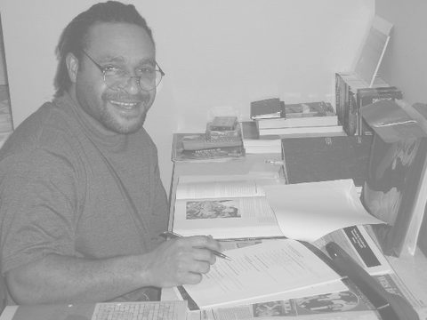

My name is Benjamin Aska; I was born in Kudjip, a local hospital in the Western Highlands Province of Papua New Guinea, on the 1st of August 1979. I come from a family of three mothers and a father; I have five half brothers and seven half sisters from my two step mothers. My two sisters and my brother and I come for the same parents.

I completed six years of primary education in Fatima primary school and went on to Fatima secondary school for my secondary education. After completing my grade twelve (12) in 1998, I attended the Don Bosco Institute of Technology in Barawaghi and studied electricity for three years,from year 2000 to 2002. I graduated in 2002 with a certificate in electrical technology.

During the years that I was in the secondary school, I began to establish contacts with the Brothers of Charity to show my interest in joining their congregation. The contact had been through numerous correspondence with Brother Jef De Wit, and through letters and visits during holidays and weekends to the Brothers’ community in Fatima.

I received a letter from Br. Jef De Wit, during my graduation in 2002, inviting me to start my Postulancy with the congregation, which began in the year 2003. I accepted his invitation and began my Postulancy in February until September that year; on the 18th of September 2003 I left Papua New Guinea bound for Belgium to start my novitiate. I was still a postulant, so along with other postulants from different countries, I stayed in kneselare, a village in West Flanders The purpose of this period was to get acquainted with each other and to study English to prepare us for the International Novitiate in Maria Aalter.

On the 1st of September 2004, we started our novitiate after an oblation ceremony. During my period of novitiate I learnt the constitution of the Brothers of Charity and the catechism of the Catholic Church and was given time to discern my vocation as a Brother of Charity. The first six months of the second year of novitiate was spent in Kruibeke to get acquainted with the apostolic works of the congregation by studying the different fields in which the congregation was engaged; especially, special education and psychiatric nursing.

On the 9th of March 2005 I left Belgium for Papua New Guinea to complete the second part of the novitiate by actively working in the services that the brothers have in Papua New Guinea. At the end of my formation, as a novice I made my first profession at the hand of the provincial superior of Asia Br. Bavo van Dingnene, on the 27th of August 2005.

During the time that I was in Kruibeke, I was invited by the general superior of our congregation Br. Rene Stockman, to return to Belgium to study for a post-degree in special education. Therefore, I left Papua New Guinea on the 28th of August 2006 and arrived in Moerzeke to start my studies.

After completing my studies I would like to go back to my country and work with the disabled and neglected citizens in our services. I want to help Br. Jackobus with the CBR program that was designed to help in educating families that have disabled children or relatives on issues such as nutrition and health status. The programe is also designed to educate the disabled especially those who are able to learn some basic necessities of daily living activities like toileting and self feeding. However, if I am given the choice to continue studying then I would study further.

In 2011, I hope to be in Papua New Guinea working in our old vocational school, educating young boys, who dropped out of primary school. I will be educating them to be good productive citizens of our society.

I would like to conclude that, as a Brother of charity and an educator, I am very much interested in helping the young boys, who miss out on formal education, to be useful and to have something to offer to their society. At the moment those young boys are not occupied, since they lack the skill and knowledge to make them feel useful and actively working. Therefore they tend turn to criminal activities and drugs.

My future in the apostolic life is still not certain even though I am able to make some predictions; however I am quiet content with my religious life.

